**Duplicated Job Check Tool**

1. **The context**

Since we have lacked control over job quality since 2021 due to limited manpower, a lot of complaints about job quality arose, along with the new job created numbers increasing on our job platform.

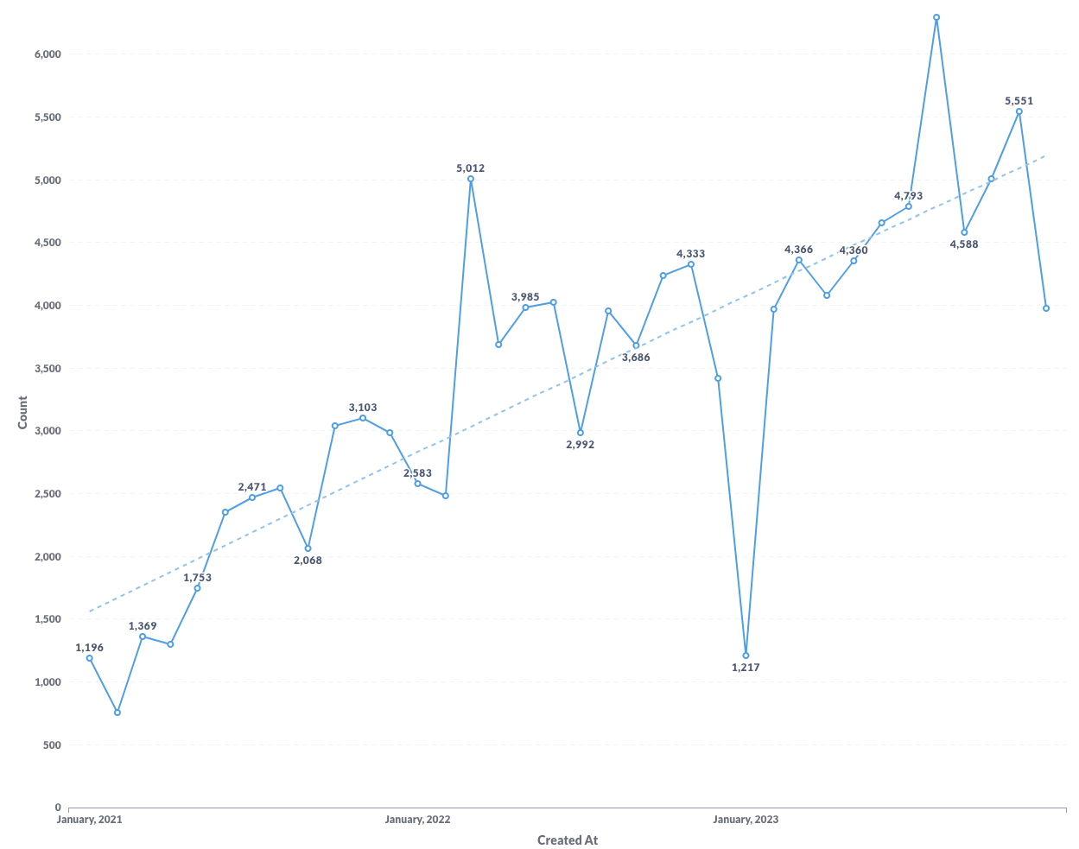

*Monthly job created from Jan 2021 to Dec 2023*

2. **The first analysis of Job Quality**

2.1 **Data source**

* Date range: Jobs created last 30 days from 6 Dec 2023 in VN
* Created a criteria checklist for Job Quality from user complaints and internal discussion, here're a few criteria for the analysis:
* Job
* Duplicated Jobs
* Fraud Report Jobs
* Incorrect Categorized Jobs
* Incorrect Salary Info Jobs
* Short Description Jobs
* Title With Icon Jobs
* Company
* Rejected / Unverified Companies
* No Tax Number Companies
* No Logo Companies

2.2 **Analyze data**

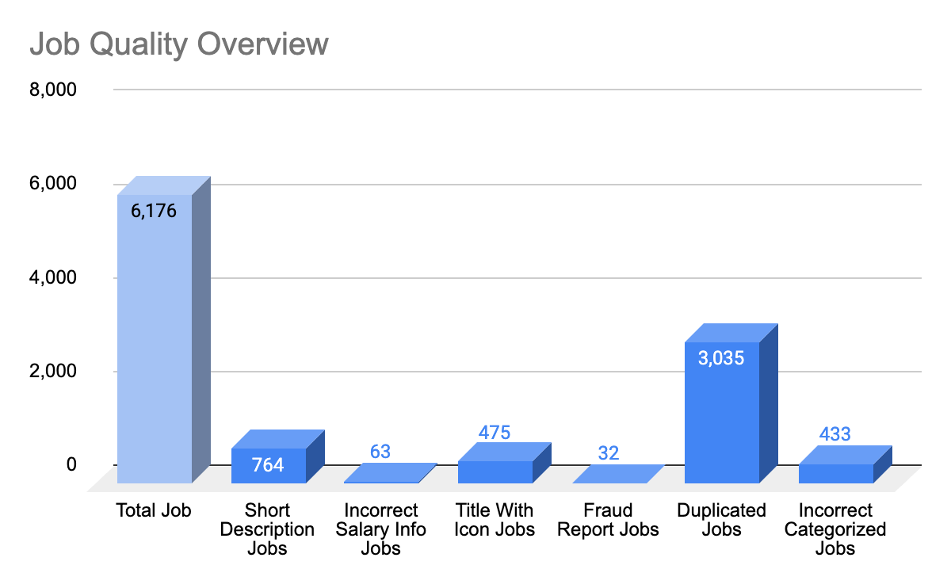

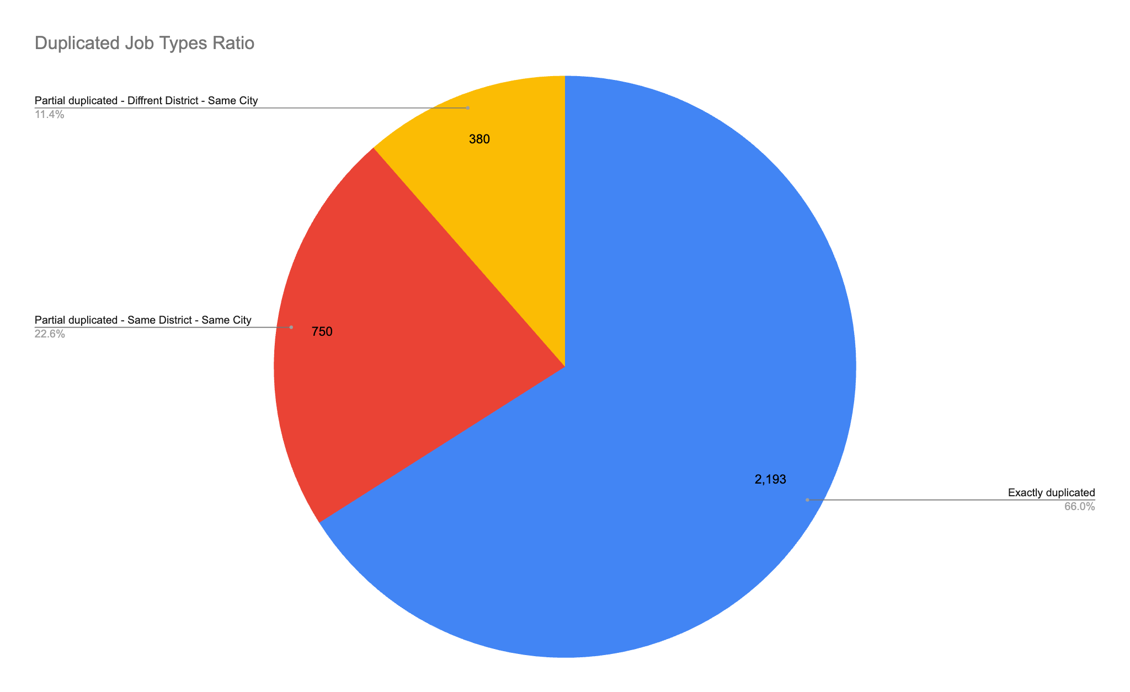

There're 3 types of duplicated jobs here:

1. Exactly duplicated:
2. Exactly same: Job Title, Job Description, Job's Company Name, Job's Location
3. Partial duplicated - Same District - Same City:
4. Similar: Job Title, Job Description
5. Exactly same: Job's Company Name, Job's Location - District level
6. Partial duplicated - Different District - Same City:
7. Similar: Job Title, Job Description
8. Exactly same: Job's Company Name, Job's Location - City level

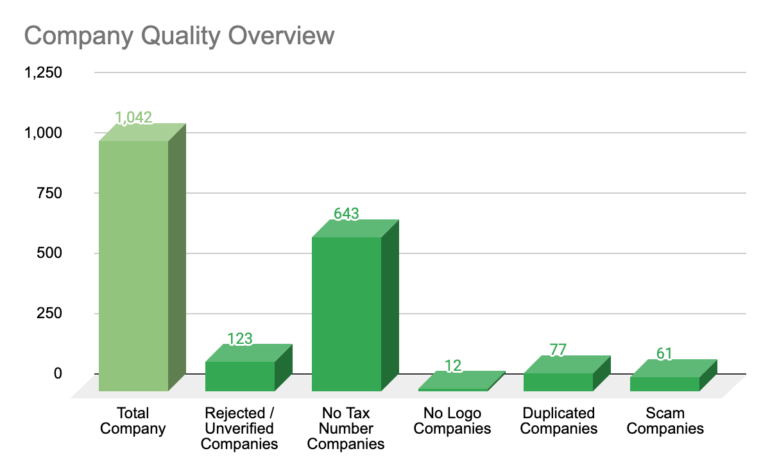

2.3 **Actionables**

3. **Main focus - Duplicated Job Check**

3.1 **Ver 1 - Manually check**

3.2 **Ver 2 - Python Script**

Included:

1. Exactly Duplicated Jobs Check
2. Exact job_title
3. Exact job_description
4. Exact job_district
5. Exact company_name
6. Partial Duplicated - Same District Jobs Check
7. Exact job_category
8. Exact job_district
9. Exact company_name
10. Partial Duplicated - Different District Jobs Check
11. Exact job_category
12. Different job_district
13. Exact job_city
14. Exact company_name
15. Duplicated Companies Check
16. Exact company_name
17. Exact company_city

3.3 **Ver 3 - Python Script - Optimized**

Since the checker is still overcounted compared with the actual number of duplicated jobs, we decided to improve the checker to be more accurate.

**Reason**

Investigated on the incorrect cases by the checker, we found out some reasons behind the inaccurate:

1. No condition for Job Type in the checker:
2. There are same-title jobs but in different types: FULL_TIME, PART_TIME and PROJECT_BASED, which are actually not considered a duplicated case.
3. Jobs in the same category, but actually are different job titles.
4. Example:
5. Job Title 1 : "Accountant - Internal" in Category "Accountant"
6. Job Title 2 : "Accountant - Outsourcing" in Category "Accountant"
7. In this example, both are in "Accountant" category, but the working responsibilities and team are different, which having different Job Description

**Adjustment**

Based on these 2 reasons, we modified the script with:

1. Added different job_type (full-time, part-time, intern) condition
2. Added 80% Similarity in Job Description condition

**Result**

We did the manual check to have the Actual Duplicated Jobs numbers for 4 weeks. Result of checker optimization:

* Before change:
* ***Checker*** *- % Duplicated Jobs/ Total Open Jobs:* 40.39%
* ***Actual*** *- % Duplicated Jobs/ Total Open Jobs:* 23.62%
* After change:
* ***Checker*** *- % Duplicated Jobs/ Total Open Jobs:* 16.70%
* ***Actual*** *- % Duplicated Jobs/ Total Open Jobs:* 16.45%





* *% Duplicated Jobs/Open Jobs (est): from the checker*
* *% Duplicated Jobs/Open Jobs (act): actual manual check*

Similarity 80%

|  |  |
| --- | --- |
| **Pros**   * Can quick spot on these cases: * Shuffle title but the job description is similar * Title EN - VN but the job description is similar * It's a better bypass job with a similar title but actually different jobs - Since the descriptions are different. Example: * Nhân viên kinh doanh kênh otc khu vực cần thơ * Nhân viên kinh doanh etc khu vực cần thơ | **Cons**   * Can't spot on cases: * Short description * Mix description (Same description but different arrangement) * Shuffled title and description * 1 job - split into 2 jobs, each job has a half-description * Low spot rate on fraud cases: * Since fraud would have shuffled title and description jobs, it didn't catch the fraud very well. * Can build a machine learning model to detect fraud cases |

**Accuracy check**

We will use this accuracy model below to check on 2 versions:

1. Version 1:
2. Exactly same: category_l3, company_name, job_district
3. Version 2:
4. Exactly same: category_l3, company_name, job_district, job_type
5. 80% similar in: job_description

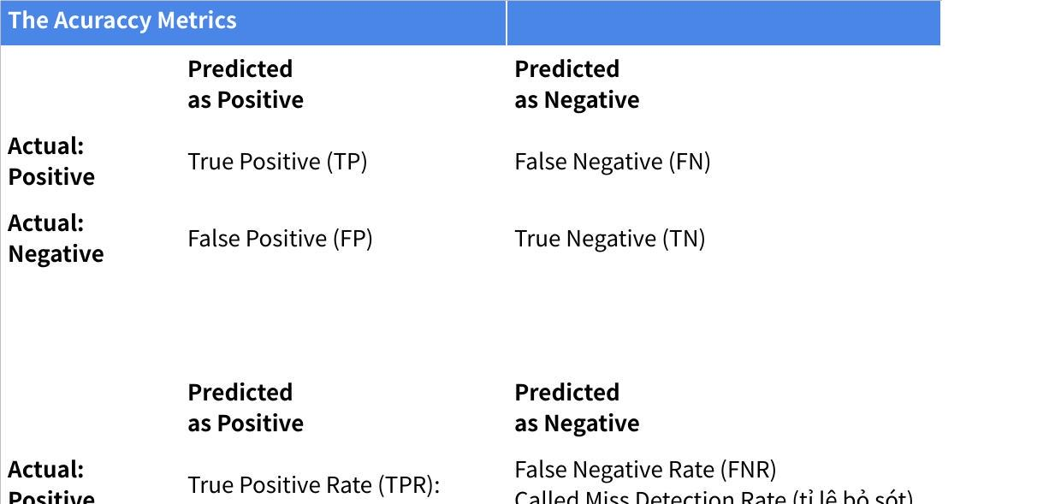

**Click the image to view the sheet.**

**1st Check - Date: 05/28/24**

|  |  |
| --- | --- |
| **Click the image to view the sheet.** | **Click the image to view the sheet.** |

**2nd Check - Date: 06/10/24**

|  |  |
| --- | --- |
| **Click the image to view the sheet.** | **Click the image to view the sheet.** |

|  |  |
| --- | --- |
| Ver 1   * Better at **correctly identifying true positives** but at the cost of a higher False Positive Rate. * If we want to minimize missed positives (i.e., **ensure that all true positives are detected, even if it means more false alarms**), Version 1 is better. | Ver 2 - Similarity 80%   * Better at **correctly identifying true negatives** but at the cost of missing more true positives. * If we want to minimize false positives (i.e., **reduce the number of false alarms, even if it means missing some true positives**), Version 2 is better. |

**Conclusion**

**We can use this tool for 2 purposes:**

1. **Internal check**: Using both 2 versions to investigate since it better covers almost duplicated/ scam cases
2. **Auto block duplicated algorithm**: If we want to block employers from posting duplicated jobs, we can use Version 2 since it has a low false alarm rate

Other than that, we can still explore more to develop version 3 since the accuracy of both versions above is still not very high.

Rule base: f1 score => Include more features.

Separate fraud and duplicated model.